**Data Normalization**

Team Members :-

Aakash Rajawat- 002764127

Diya Baldota- 002747966

Hardik Sodhani- 002770306

Rucha Chotalia- 002711888

Table: Housing Data

The housing data was not in 1NF as it had multiple data in single column

Solution: Data was normalized using python script to bring in 1NF form

<https://colab.research.google.com/drive/1CiiHFNYYM0Xm1kVO_wpWN4JUUlL3zaz7#scrollTo=wYWrxajRF3yD>

Data:-

*Before Normalizing*

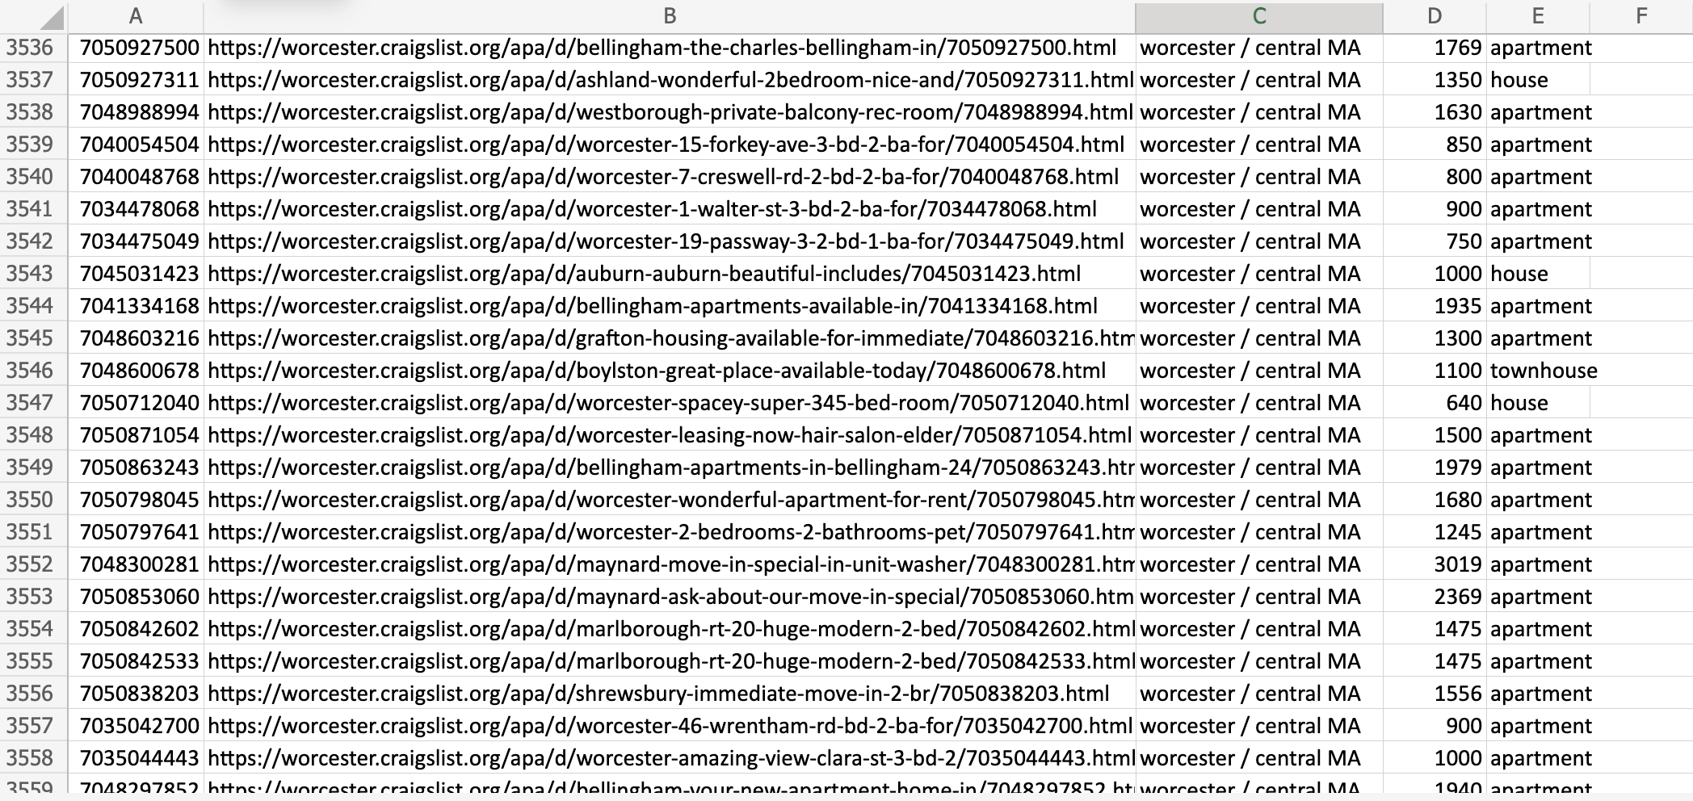

After Normalizing in 1NF :-

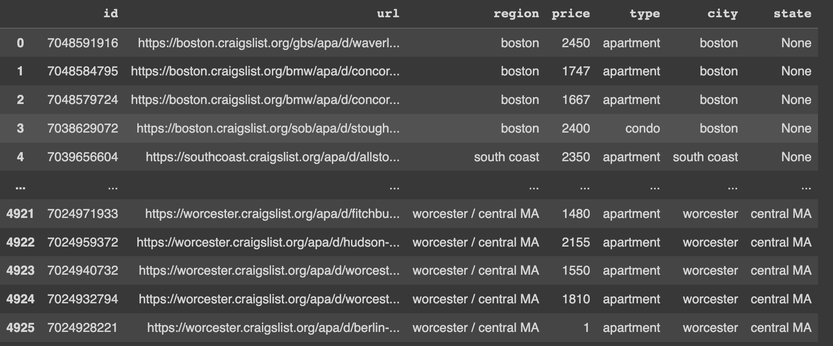

**3rd Normal Form:**

· For the table to be in 3rd Normal Form, it must satisfy the conditions of 1st Normal Form and 2nd Normal Form.

· The table is now satisfying the 2nd Normal Form.

· There are no partial and transitive dependencies in the table. So the table is now in 3rd Normal Form.

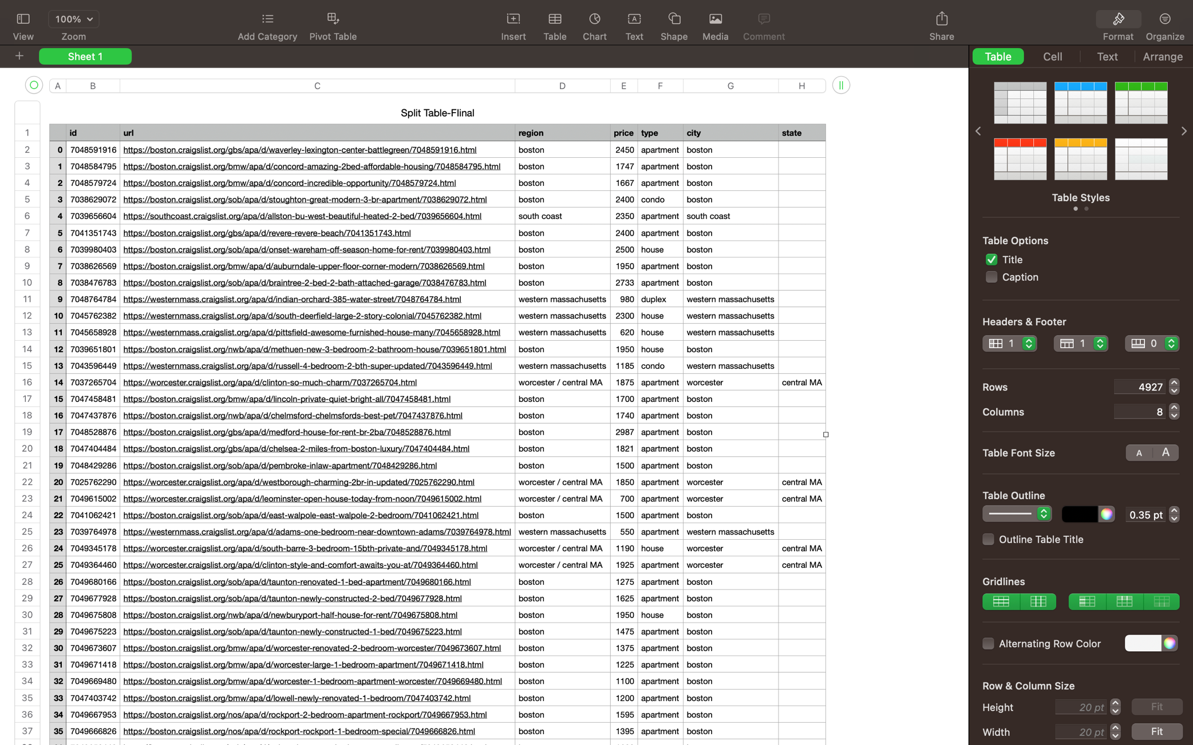

2nd Normal Form:

· For the table to be in 2nd Normal Form, it must satisfy the conditions of 1st Normal Form.

· The table has now been converted into 2nd Normal Form

· This table does not contain partial dependency.

As this table, fulfils all the above criteria, it is said to be in 2nd Normal Form.

**VIEW SQL queries:**

1. CREATE VIEW beds AS(

SELECT dmddapt1.id, dmddapt2.beds, dmddapt2.sqfeet FROM dmddapt1 INNER JOIN dmddapt2 ON dmddapt1.id=dmddapt2.id);

1. CREATE VIEW laundry AS(

SELECT dmddapt1.id, dmddapt2.beds, dmddapt2.laundry_options FROM dmddapt1 LEFT JOIN dmddapt2 ON dmddapt1.id=dmddapt2.id);

1. CREATE VIEW region AS(

SELECT dmddapt1.id, dmddapt2.region, dmddapt2.sqfeet FROM dmddapt2 RIGHT JOIN dmddapt1 ON dmddapt1.id=dmddapt2.id) ;

1. CREATE VIEW sqfeet AS(

SELECT dmddapt1.id, dmddapt2.region, dmddapt2.sqfeet FROM dmddapt2 INNER JOIN dmddapt1 ON dmddapt1.id=dmddapt2.id ORDER BY dmddapt2.sqfeet DESC);

1. CREATE VIEW area AS(

SELECT dmddapt1.type, dmddapt2.sqfeet FROM dmddapt2 INNER JOIN dmddapt1 ON dmddapt1.id=dmddapt2.id) ;

1. CREATE VIEW price AS(

SELECT AVG(dmddapt1.price) FROM dmddapt2 INNER JOIN dmddapt1 ON dmddapt1.id=dmddapt2.id) ;

1. CREATE VIEW state AS(

SELECT state, count(image_url) as count FROM dmddapt4 GROUP BY state);

1. CREATE VIEW id AS(

SELECT COUNT(id) as count, region FROM dmddapt2 GROUP BY region);

1. CREATE VIEW carpet AS(

SELECT dmddapt1.id, dmddapt2.beds, dmddapt2.sqfeet FROM dmddapt1 INNER JOIN dmddapt2 ON dmddapt1.id=dmddapt2.id where dmddapt2.laundry_options like '%laundry in bldg%' or dmddapt2.laundry_options like '%laundry on site%');

1. CREATE VIEW bhk AS(

SELECT dmddapt1.id, dmddapt1.price, dmddapt1.type, dmddapt2.region FROM dmddapt1 INNER JOIN dmddapt2 ON dmddapt1.id=dmddapt2.id where dmddapt2.region = 'Boston' and dmddapt1.type like '%apartment%');

1. CREATE VIEW apperance AS(

SELECT dmddapt1.id, dmddapt2.region, dmddapt2.sqfeet FROM dmddapt2 RIGHT JOIN dmddapt1 ON dmddapt1.id=dmddapt2.id) ;

1. CREATE VIEW apartment AS(

SELECT * FROM dmddapt1 JOIN dmddapt4 ON dmddapt1.id=dmddapt4.id where dmddapt1.type = 'apartment' and dmddapt4.image_url IS NOT NULL);

1. CREATE VIEW boston AS(

SELECT dmddapt1.id, dmddapt1.price, dmddapt1.type, dmddapt2.region FROM dmddapt1 JOIN dmddapt2 ON dmddapt1.id=dmddapt2.id where dmddapt2.region = 'Boston' and dmddapt1.type like '%apartment%');

1. CREATE VIEW morethanprice AS(

SELECT dmddapt1.id, dmddapt1.price, dmddapt2.region FROM dmddapt1 JOIN dmddapt2 ON dmddapt1.id=dmddapt2.id where dmddapt2.sqfeet > 700 and dmddapt1.type like '%apartment%' ORDER BY dmddapt1.price DESC);

1. CREATE VIEW unit AS(

SELECT dmddapt1.id, dmddapt1.price, dmddapt2.beds,dmddapt2.laundry_options FROM dmddapt1 JOIN dmddapt2 ON dmddapt1.id=dmddapt2.id where dmddapt2.laundry_options='w/d in unit');

1. CREATE VIEW bedsthan AS(

SELECT dmddapt1.id, dmddapt1.price, dmddapt2.beds,dmddapt2.beds FROM dmddapt1 JOIN dmddapt2 ON dmddapt1.id=dmddapt2.id where dmddapt2.beds>1);

1. CREATE VIEW regioning AS(

SELECT DISTINCT dmddapt2.region, dmddapt2.sqfeet FROM dmddapt2 RIGHT JOIN dmddapt1 ON dmddapt1.id=dmddapt2.id) ;

1. CREATE VIEW petting AS(

SELECT dmddapt1.id, dmddapt3.cats_allowed, dmddapt3.cats_allowed FROM dmddapt3 RIGHT JOIN dmddapt1 ON dmddapt1.id=dmddapt3.id );

1. CREATE VIEW bedss AS(

SELECT dmddapt1.id, dmddapt1.price, dmddapt2.beds,dmddapt2.beds FROM dmddapt1 JOIN dmddapt2 ON dmddapt1.id=dmddapt2.id where dmddapt2.beds>1);

1. CREATE VIEW idssss AS(

SELECT dmddapt1.id, dmddapt2.beds, dmddapt2.laundry_options FROM dmddapt1 LEFT JOIN dmddapt2 ON dmddapt1.id=dmddapt2.id);

ER diagram:

